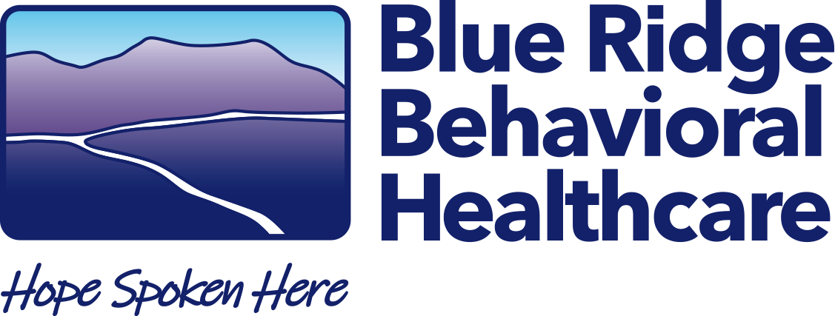
The Burrell Center

MEMORANDUM

Date: November 21, 2024

To: All Potential Offerors on RFP #2024EHR

From: Helen Lang, CQI Officer

RE: Amendment to RFP

The Request for Proposals – RFP #2024EHR issued on October 1, 2024 is being amendment to extend the deadline date for seal submission. Sealed proposal will be received until 11:59 PM, EST, Friday, December 6, 2024.

If you have any questions, please contact me at hlang@brbh.org.

Respectfully,

Helen Lang, CQI Officer
Blue Ridge Behavioral Healthcare

